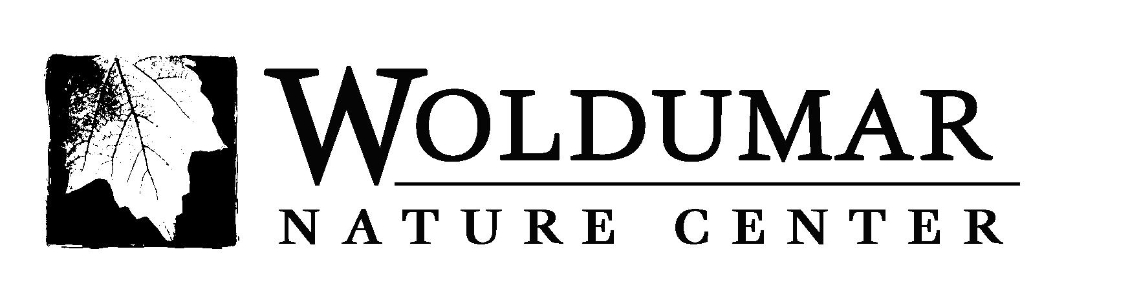
In Loving Memory of

___________________________________________________________

_______________________________________________________________________________
Donor Name
_______________________________________________________________________________
Address City/State/Zip Telephone

I/We wish to give $ _________________ to Woldumar Nature Center

❑ Check enclosed  Please bill me  Credit Card
(checks payable to: Woldumar Nature Center)

□ MasterCard □ Visa Card Number _______________________________ Exp. Date___/____

Signature________________________________________________Today’s Date:____________

Acknowledgement will be sent to the Donor and to the Family of the Deceased.

All Contributions to Woldumar are tax deductible.

About Woldumar
Woldumar Nature Center is located on the west side of Lansing. It is the area’s only self-funded, 501(c)3 non-profit nature center. It offers 5 miles of natural trails on 178 acres and year-round community and educational programs. Over 40,000 children and adults participate in the center’s activities that include summer day camps, year-round scouting programs, field trips and science curriculums for classrooms, outings for all ages, and facility space for groups or events. Donations help the center achieve its mission to educate people about the natural environment. Visit www.woldumar.org for more information.

